**Name: Arfanul Kabir Apurbo**

**ID: 18-37135-1**

**Section: [ B ]**

**Course: Computer Vision and Pattern Recognition**

**Title: CNN model to classify the MNIST handwritten dataset**

**Abstract:**

Because handwritten information differs from person to person, automatic recognition of handwritten digits from visual data can be challenging. My major goal for this project is to propose a simple convolutional neural network (CNN) model to classify the MNIST handwriting dataset with a test accuracy of above 98 percent, as well as to compare and contrast different optimizers.

**Introduction:**

Despite the fact that the dataset is effectively solved, it may be used to learn and practice how to build, analyze, and apply convolutional deep learning neural networks for image classification from the ground up. This includes how to create a robust test harness for estimating the model's performance, how to investigate model enhancements, and how to save and load the model to make predictions on new data. Because handwritten information differs from person to person, automatic recognition of handwritten digits from visual data can be challenging. My major goal for this project is to propose a simple convolutional neural network (CNN) model to classify the MNIST handwriting dataset with a test accuracy of above 98 percent, as well as to compare and contrast different optimizers.

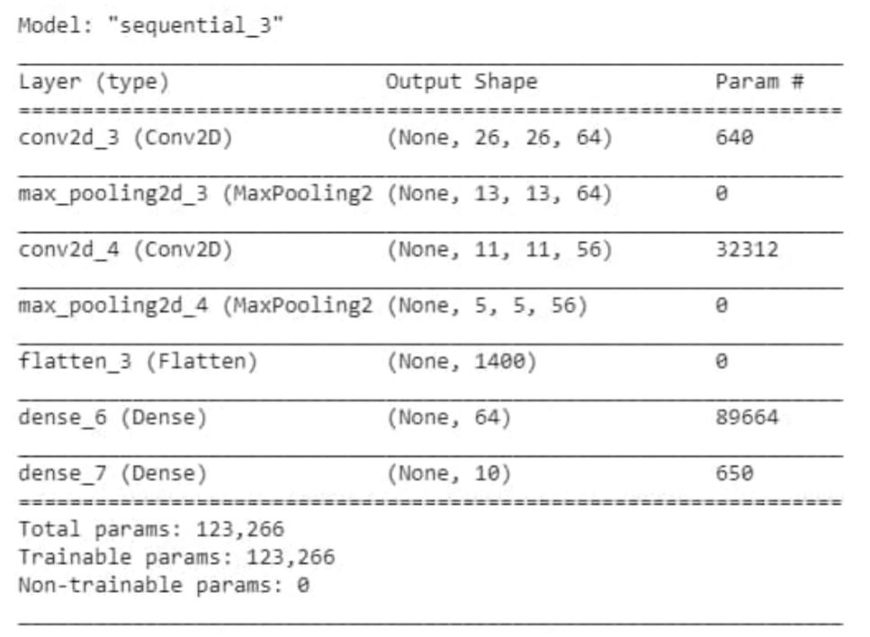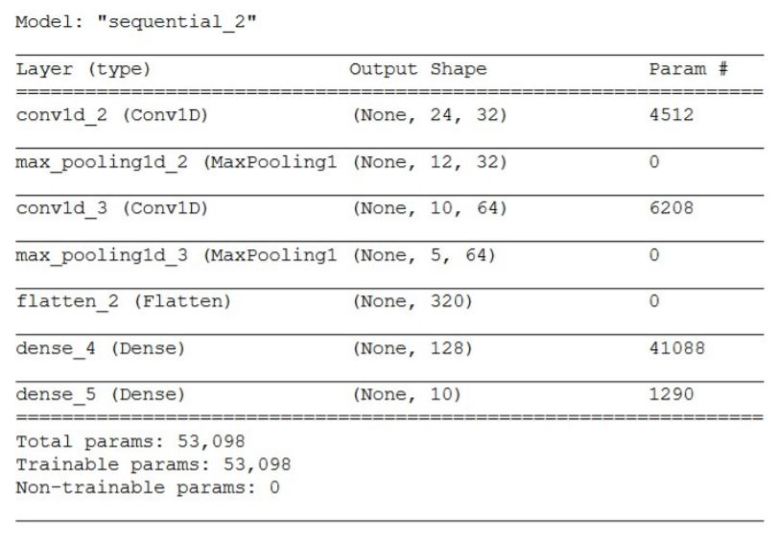

**Result:**

**CNN model 1 Loss For SGD**

|  |  |  |  |
| --- | --- | --- | --- |
| **Optimizer** | **Train Accuracy(percent)** | **Validation Accuracy(percent)** | **Test Accuracy(percent)** |
| RMSprop | 99.53% | 98.45% | 98.72% |
| SGD | 92.08% | 92.27% | 93.66% |
| Adam | 98.66% | 97.96% | 98.33% |

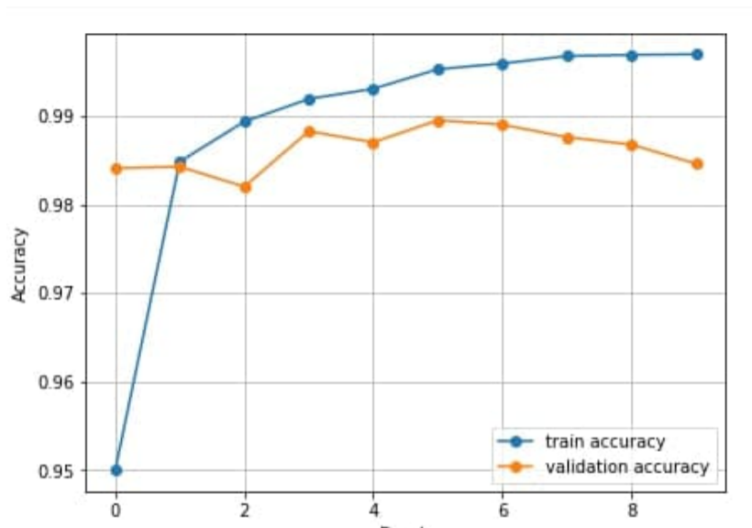

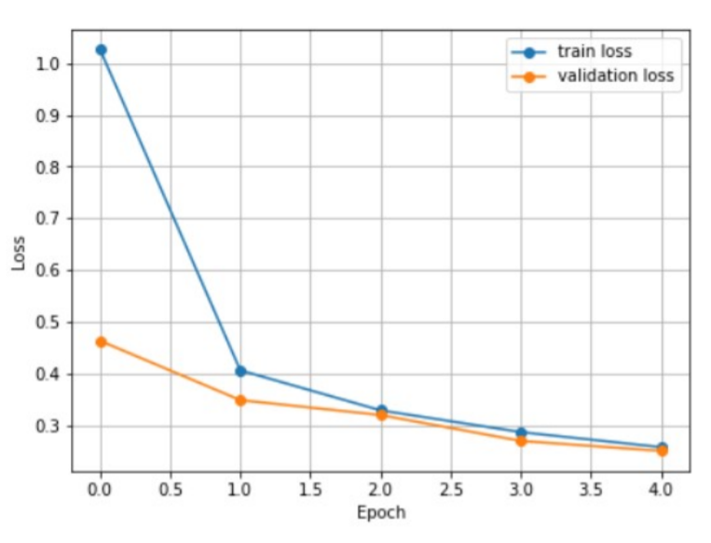

**CNN model 1 Loss For ADAM**

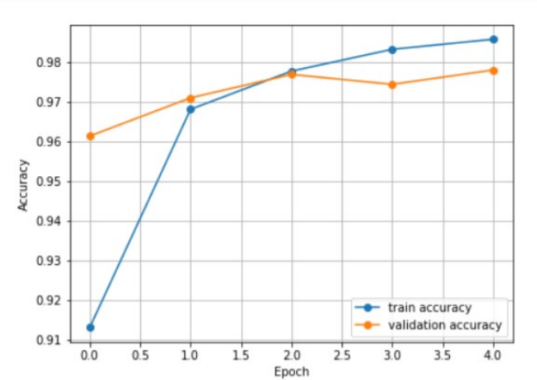

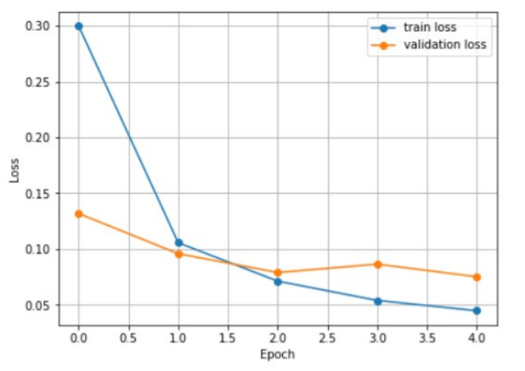

**CNN model 1 Loss For RMSprop**

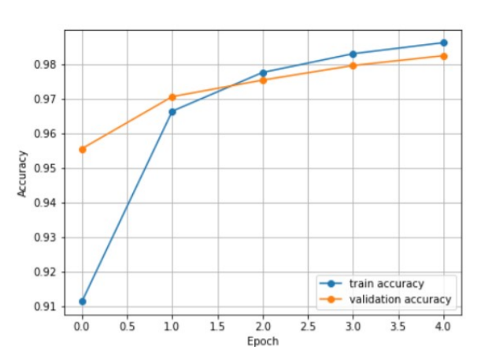

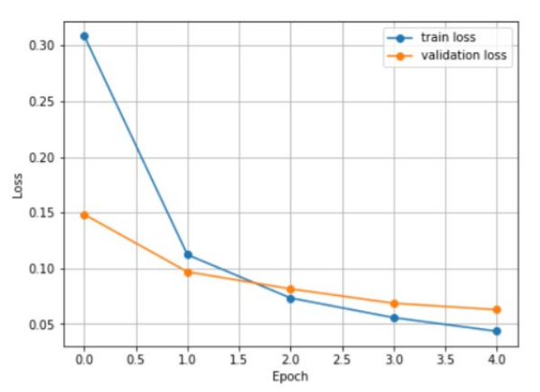

|  |  |  |  |
| --- | --- | --- | --- |
| **Optimizer** | **Train Accuracy(percent)** | **Validation Accuracy(percent)** | **Test Accuracy(percent)** |
| RMSprop | 99.39% | 98.50% | 98.79% |
| SGD | 93.79% | 94.05% | 94.49% |
| Adam | 99.39% | 98.10% | 98.36% |

**Discussion:**

However, the graph analysis reveals a disparity in Train and Validation accuracy, implying that the model would not perform consistently in real-world data. The RMSprop optimizer of the 'Model 1' graph shows a relatively equal rate of Train and Validation accuracy, indicating that the model will perform better in real-world data.

RMSprop exhibited the best validation and testing accuracy, as well as the least training loss. It is not the ideal solution because it has the largest validation loss. Taking into account all of the information, we can infer that employing the SGD optimizer will get the best results from this model. It has the best training and testing accuracy as well as the least validation loss.